**SOFTWARE DESIGN AND ARCITECTURE**

**Submitted to: Sir Mukhtiar Zamin**



**LAB ASSIGNMENT 1**

**Submitted by: Maryam Khan**

**Roll no: SP23-BSE-066**

**Date: 17th April 2025**

DEPARTMENT OF SOFTWARE ENGINEERING

COMSATS UNIVERSITY ISLAMABAD

ABBOTTABAD CAMPUS

**TRANSPORT MANAGEMENT SYTSEM**

USE CASE: Track Vehicle Location

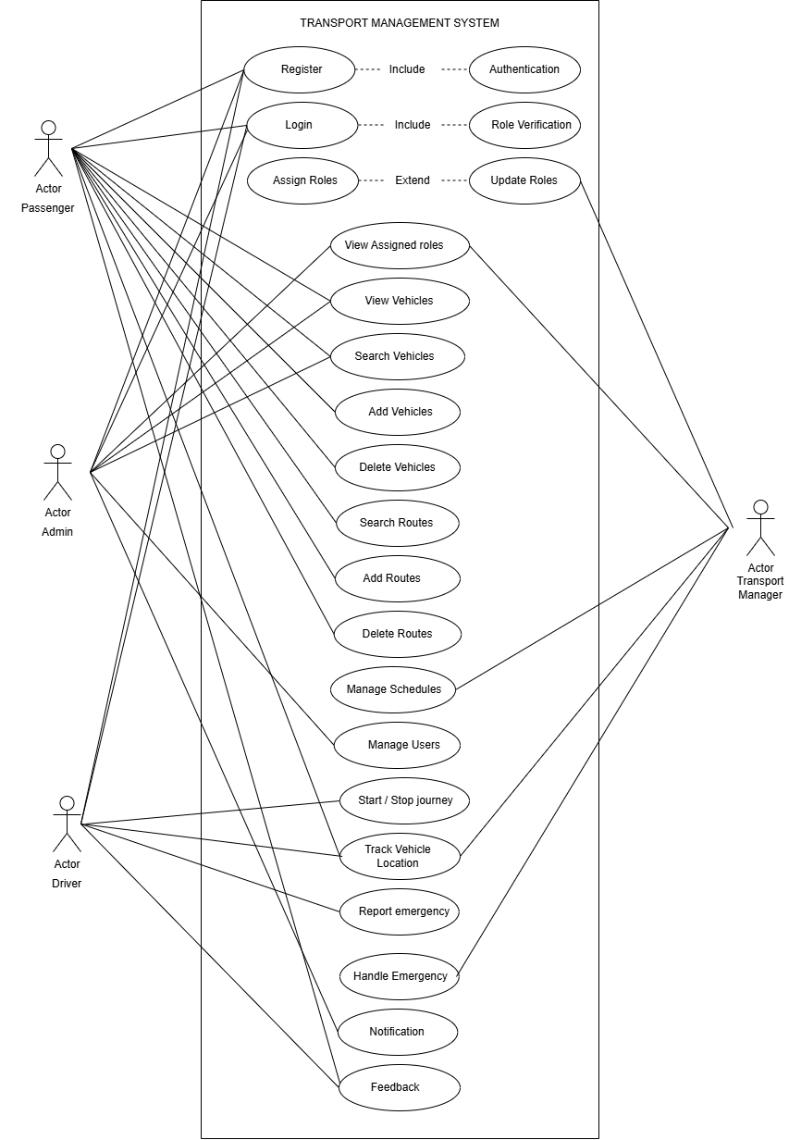

**FULLY DRESSED USE CASE OF TRACK VEHICLE LOCATION**

|  |  |
| --- | --- |
| USE CASE 1D | UC-1 |
| USE CASE NAME | Track Vehicle Location in a Transport Management System |
| Actor | Primary Actor: Passenger, Transport Manager  Secondary Actor: System |
| Description | This use case allows Transport managers and users to view a vehicle's real-time location on a map using GPS data, helping with monitoring, route tracking, and arrival updates. |
| Trigger | The user (Transport Manager or passenger) selects the option to track a vehicle's location from the system dashboard or mobile app. |
| Pre-Condition | PRE-1: The vehicle has a GPS tracking device installed inside it.  PRE-2: The device has a GPS module, microprocessor, 4G SIM, and power source.  PRE-3: Server application is running on the correct protocol and port.  PRE-4: Frontend is built and is able to call backend. |
| Post Condition | POST-1: Location of vehicle is accurately measured by the tracker.  POST-2: The location is send to the server via 4G network.  POST-3: Server receives the data and store it in the database.  POST-4: Real-time position is displayed to authorized users on a map UI. |
| Normal Flow | 13.0 Track Vehicle Location   1. When the user clicks on the GPS tracking button the satellites start sending signals to the GPS module inside the tracker. 2. Inside the module the antenna receives the signals and cleans and amplifies it. Then the GPS processor decodes the signals and gives output in the form of location. 3. 4G SIM installed in the tracker takes the signals to the server IP through the custom port using TCP or UDP protocol. 4. Server receives the data and stores it in database. 5. When accessed through the Web or mobile, server queries the database and gives the exact location. 6. The location is then displayed on the Google map where markers displays the location of vehicle. |

|  |  |
| --- | --- |
| Alternative Flow | **1a. No GPS Signals**  4a1. GPS is not able to get the signals from the satellite and displays on the screen “Location unavailable”  **2a. GPS module not working**  2a1. There is a problem in the hardware of the module.  2a2. Displays a warning: Vehicle not connected. Last update at timestamp.  **3a. No Internet**  3a1. Location is buffered in device memory  3a2. Shows message: Send later when the signal is back.  **4a. Server not available**  4a1. Server is not responding so the system displays message “Resend message”.  4a2. If retries fail, device may switch to a backup server (if configured).  **5a. Privacy mode**  5a1. User has enabled the privacy mode.  5a2. Location can be viewed inside the car but not on other people devices. |
| Exceptions | • **Vehicle Not Connected:**   * GPS device is offline or not transmitting data. * System displays the last known location with a warning.   • **Map API Fails:**   * If the map fails to load, show fallback coordinates or an error message.   • **Unauthorized Access:**   * A user tries to access tracking without proper permissions. System denies access.   • **Vehicle Not Found:**   * The selected vehicle ID doesn't exist or has been removed from the system. |
| Business Rules | • Vehicle location data must refresh at regular intervals (e.g., every 10 seconds).  • Only authorized users (Transport managers or assigned users) can access tracking information.  • Users can only track vehicles assigned to their specific trip or booking.  • All tracking actions should be logged for audit and security purposes.  • The system should store vehicle location history for reporting and analysis.  • Map display must be consistent and accurate based on the GPS coordinates received.  • If a vehicle stops transmitting location, the system must indicate it with the last known location timestamp.  • Users must not be able to spoof or modify location data manually. |
| Assumptions | 1. All vehicles are equipped with functioning GPS tracking devices. 2. There is a reliable internet connection for both GPS and user devices. 3. Passengers are informed of which vehicle they are linked to (e.g., via booking ID). 4. Map API integration is properly configured and available. 5. Users are familiar with basic map interaction (zoom, pan, select vehicle). |

**OPERATIONAL CONTRACT**

|  |  |
| --- | --- |
| OC-1D | OC-TVL-01 |
| OC- NAME | Track Vehicle Location ( deviceId, gpsCoordinates, timestamp, serverIP, port) |
| Cross Ref | Use Case: UC-001: Track Vehicle Location  **Subsystems**: GPS Module, Network Layer, Server Backend, Cloud Storage  **Related OCs**:   * OC-TVL-02: readLocationFromGPS() * OC-TVL-03: prepareDataPacket() * OC-TVL-04: sendDataToServer() * OC-TVL-05: receiveDataOnServer() * OC-TVL-06: storeLocationData() * OC-TVL-07: getVehicleLocation() |
| Pre-Conditions | • GPS module is powered and has locked onto at least 4 satellites.  • SIM card is active and mobile data (4G/5G) is available.  • Device is configured with the correct server IP and port.  • The server is online and listening. |
| Post Conditions | * GPS data was successfully retrieved. * An object named “**location**” was created using attributes like latitude, longitude, altitude, timestamp. * Association of location object was created with **vehicletracker** object. * A new object named **datapackage** was created that contained location data and some meta data. * Association was created between vehicle tracker and network module for transmitting data. * The server received the data and stored the Location object in the persistent database * An association was created between the Vehicle entity on the server and its latest Location. * The temporary DataPacket object was destroyed after successful transmission |

**SYSTEM SEQUENCE DIAGRAM**

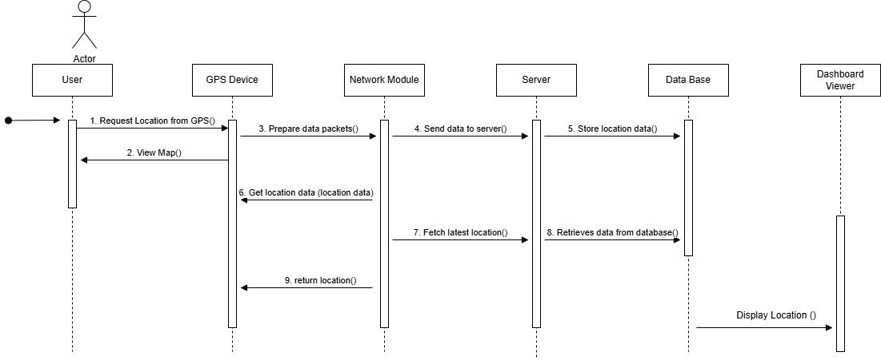

**Communication diagram**

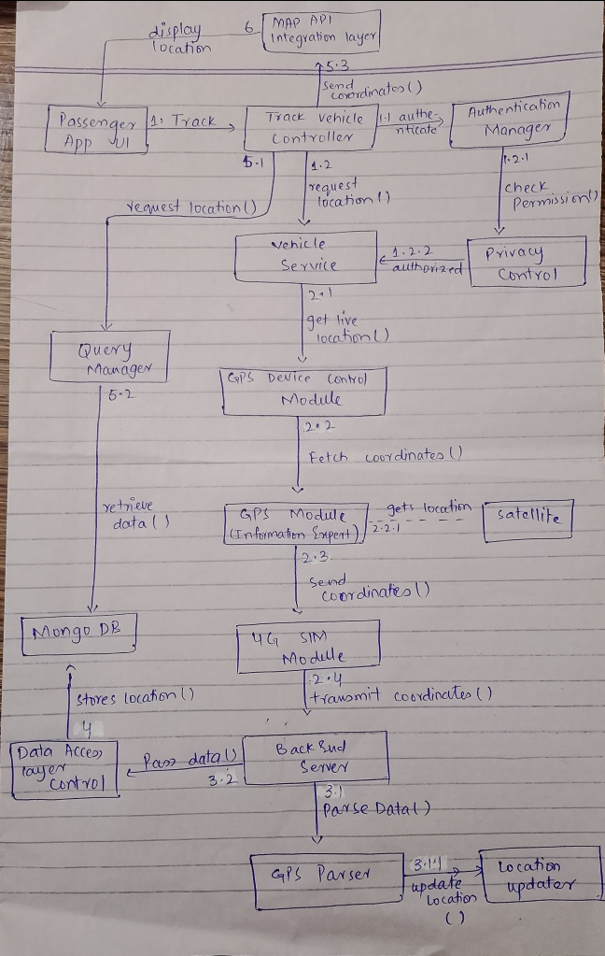

**CLASS DIAGRAM**

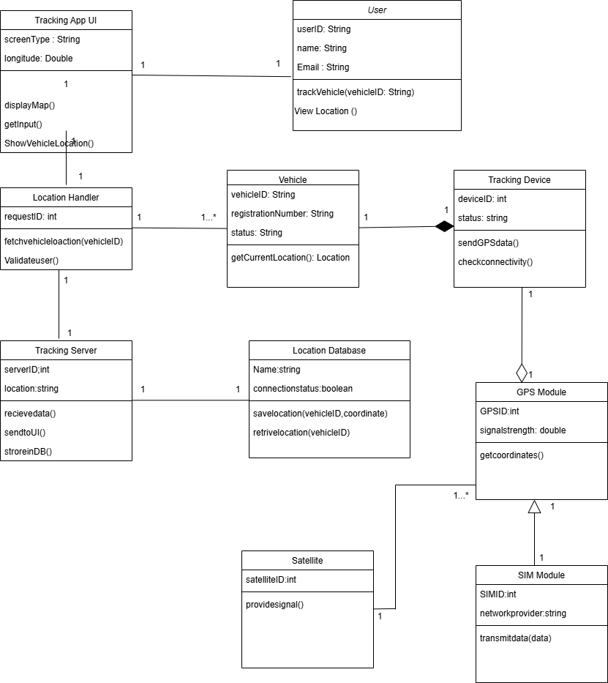

**PROTOTYPE**

